 | CICLISTICA |  | CYCLE
CODICE | ARTICOLO |  | ITEMS | INC.IVA
100.000 | TELAIO NUDO X MINI/MIDI 95/02 |  | MINI/MIDI 95/02 FRAME | 276,15
100.000/A | TELAIO NUDO X ECONOMICA |  | ECO TYPE FRAME | 257,54
100.000/B | TELAIO NUDO X MIDI DA NOLEGGIO |  | MIDI Rental FRAME | 264,70
100.000/C | TELAIO NUDO X MIDI 203F |  | MIDI 203F FRAME | 276,15
100.000/D | TELAIO NUDO X MINI - MIDI 204/205/206/207 |  | MINI/MIDI 204/205/206/207 FRAME | 300,48
100.001 | CP. TRIANGOLI POST.X MINI 95/00 |  | MINI 95/00 RearTriangles (2pcs) | 83,00
100.001/A | CP. TRIANGOLI POST.X MINI 204/205-BASE STD |  | MINI 204/205-STD Version RearTriangles (2pcs) | 71,96
100.001/B | CP.TRIANGOLI POST.X MINI 2006 | 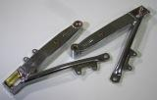 | MINI 2006 RearTriangles(2pcs) | 90,29
100.001/C | CP.TRIANGOLI POST.X MINI 2007 | 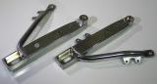 | MINI 2007 RearTriangles(2pcs) | 91,29
100.002 | CP.TRIANGOLI POST.X MIDI 95/00 |  | MIDI 95/00 RearTriangles (2pcs) | 83,00
100.002/A | CP.TRIANGOLI POST.X MIDI 204/205-BASE STD | 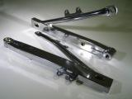 | MIDI 204/205-STD Version RearTriangles (2pcs) | 71,96
100.002/B | CP.TRIANGOLI POST.X MIDI Noleggio | 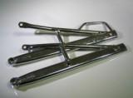 | MIDI Rental RearTriangles (2pcs) | 80,55
100.002/C | CP.TRIANGOLI POST.X MIDI 2006 | 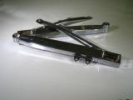 | MIDI 2006 RearTriangles (2pcs) | 90,29
100.002/D | CP.TRIANGOLI POST.X MIDI 2007 | 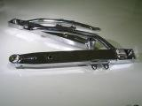 | MIDI 2007 RearTriangles (2pcs) | 91,29
100.002/E | CP.TRIANGOLI 207 IN ALL.RICAVATI DAL PIENOX MIDI | 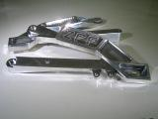 | Alu.Machined CP.Triangles 207 | 324,14
100.003 | CP.TRIANGOLI POST.X MINI 2001 X RINVIO | 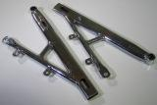 | MINI 2001 RearTriangles (2pcs).x Transmission | 98,33
100.004 | CP.TRIANGOLI POST.X MIDI 2001 X RINVIO | 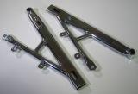 | MIDI 2001 RearTriangles (2pcs)x Transmission | 98,33
100.005 | STELO FORCELLA X NOLEGGIO DX | 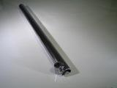 | Fork Rod x Rental RH | 13,60
100.005/A | STELO FORCELLA X NOLEGGIO SX | 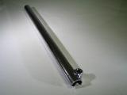 | Fork Rod x Rental LF | 13,60
100.005/B | STELO FORCELLA X NOLEGGIO SX C/SUPP.PINZA Ø125 | 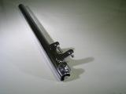 | Fork Rod x Rental LF w/Caliper Supp.Ø125 | 25,75
100.005/C | STELO FORCELLA X NOLEGGIO SX C/SUPP.PINZA Ø150 |  | Fork Rod x Rental LF w/Caliper Supp.Ø150 | 31,07
100.007 | STELO FORCELLA DX X MINI | 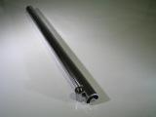 | Fork Rod x mini RH | 13,90
100.007/A | STELO FORCELLA DX X MINI STD BASE | 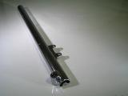 | Fork Rod x MINI RH STD Version | 13,90
100.008 | STELO FORCELLA DX X MIDI |  | Fork Rod x MIDI RH | 13,90
100.008/A | STELO FORCELLA DX X MIDI STD BASE |  | Fork Rod x MIDI RH STD Version | 13,90
100.009 | STELO FORCELLA SX X MINI C/SUPP. PINZA | 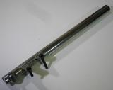 | Fork Rod x MINI LF w/Caliper Supp. | 27,19
100.009/A | STELO FORCELLA SX X MINI STD BASE C/SUPP.PINZA | 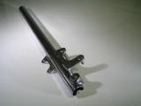 | Fork Rod x MINI STD Version LF w/Caliper Supp. | 27,19
100.010 | Parafango Post.mod.MINI 206/207 GREZZO | 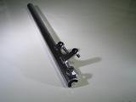 | Fork Rod x MIDI LF w/Caliper Supp. | 27,19
100.010/A | STELO FORCELLA SX X MIDI STD BASE C/SUPP.PINZA |  | Fork Rod x MIDI STD Version LF w/Caliper Supp. | 27,19
100.011 | STELO FORCELLA DX X DOPPIO FRENO A DISCO X MINI 205/205/206/207 | 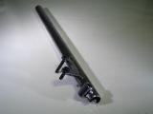 | Fork Rod RH xDouble Disc Brake MINI | 27,78
100.011/A | STELO ForcellaECO SX DiscoØ125 |  | ECO Fork Rod LF Ø125 DISC | 25,75
100.011/B | STELO ForcellaECO SX DiscoØ150 |  | ECO Fork Rod LF Ø150 DISC | 27,19
100.011/C | STELO FORCELLA ECO DX |  | ECO Fork Rod RH | 13,60
100.011/D | STELO FORCELLA ECO SX |  | ECO Fork Rod LF | 25,89
100.011/E | STELO FORCELLA DX X DOPPIO FRENO A DISCO X MIDI 204/205/206/207 |  | Fork Rod RH xDouble Disc Brake MIDI | 27,19
100.012 | CP. MANUBRIO Ø25 NORMALE | 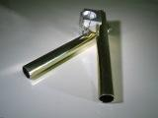 | Handlebar CP.Ø25 (2pcs) | 20,05
100.013 | CP. SEMIMANUBRIO RACING Ø25 | 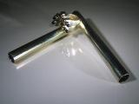 | Half-Handlebar Racing Ø25(2pcs) | 54,38
100.014 | CP. TAPPI X MANUBRIO | 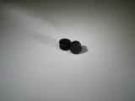 | Handlebar Caps (2pcs) | 4,30
100.015 | CP.TAPPI X FORCELLE |  |  | 4,30
100.017 | CP.Registri Tendicatena Comp.99/03 |  | ChainTightener Equalizers Compl.99/03(2pcs) | 20,05
100.017/A | CP.Registri Tendicatena Comp.ECO |  | ChainTightener Equ.Comp.ECO(2pcs) | 11,11
100.018 | CP.Registri Tendicatena Comp.204/205 | 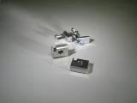 | ChainTightener Equalizers Compl.204/205(2pcs) | 30,06
100.018/A | CP.Registri Tendicatena Comp.206/207 | 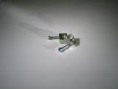 | ChainTightener Equalizers Compl.206/207(2pcs) | 25,01
100.020 | CP. PEDANE Gomma XMINI/MIDI | 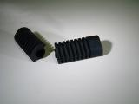 | RubberFeet Supp.MINI/MIDI (2pcs) | 5,67
100.021 | CP. PEDANE X MINI 95/03 | 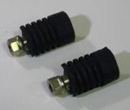 | Feet Supp.MINI 95/03 (2pcs) | 17,17
100.021/A | CP.PEDANE MINI/MIDI 204/205/206/207 | 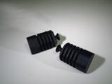 | Feet Supp.MINI/MIDI 204/205/206/207 (2pcs) | 14,31
100.022 | CP.PiastreForcella xMidi Noleggio | 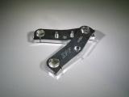 | Fork Mounts MIDI Rental | 44,36
100.022/A | CP.PiastreForcella xMiniMidi xAmmortizz.Sterzo da201a206 | 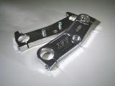 | Fork Mounts MINI/MIDIxSteering Damper from201to206 (2pcs) | 69,68
100.022/B | PIASTRA STERZO INF. 201>207 | 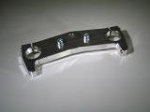 | Steering Mount Bottom 201>207 | 42,22
100.022/C | CP. GRANI xAmmortizz.Sterzo | 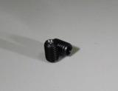 | Steering Damper Grains (2pcs) | 5,44
100.022/D | PIASTRA STERZO SUPPERIORE 2007 | 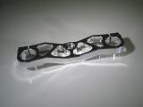 | Steering mount top 2007 | 50,27
100.023 | CP.TUBI xSemimanubrio 201>207 | 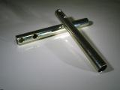 | Half-Handlebar Tubes 201>207(2pcs) | 6,59
100.023/A | CP.Tappi FissaggioManubr.206/207 | 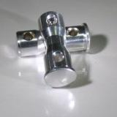 | FixingCapsHandlebars206/207(2pcs) | 10,58
100.025 | Perno Centrale Supp.Motore Mini 99/03 | 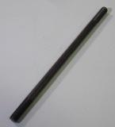 | Engine mount central pivot mini 99/03 | 6,59
100.025/A | PernoCentraleSupp.Motore Midi99/03 |  | Engine Mount Central Pivot Midi 99/03 | 6,59
100.025/B | Perno Centrale Supp.Motore 204-5-6 | 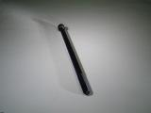 | Engine Mount Central Pivot 204-5-6 | 9,31
100.025/C | PernoCentraleSupp.Motore Noleggio | 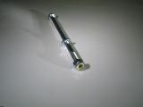 | Engine Mount Central Pivot Rental | 6,59
100.028 | CP.Pedane Comp.Midi Noleggio | 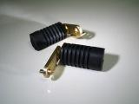 | Feet Supp.Compl.Midi Rental | 20,46
100.029 | COMANDO GAS COMPLETO NORMALE | 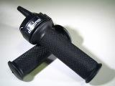 | GAS CONTROL COMPL.NORMAL | 29,96
100.029/A | CP. MANOPOLE IN GOMMA DOMINO |  | Rubber Handle Control DOMINO | 12,50
100.029/B | COMANDO GAS SEMI RAPIDO MOP | 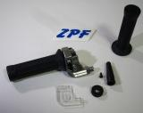 | GAS Control Half-fast | 29,11
100.029/C | COMANDO GAS RAPIDO END | 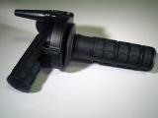 | GAS Control Fast END | 39,80
100.029/D | Coperchietto COMANDO GAS MINI | 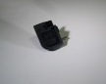 | GAS Control Lid >MINI | 1,58
100.029/E | Coperchietto COMANDO GAS MOP |  | GAS Control Lid >MOP | 3,26
100.029/F | Coperchietto COMANDO GAS END | 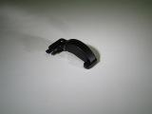 | GAS Control Lid >END | 3,29
100.029/G | REGISTRO Comando GAS Mini-END | 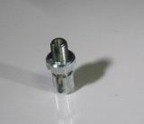 | GAS Control Equalizer MINI-END | 2,81
100.029/H | COMANDO GAS X ECO CON FERMO |  | GAS Control x ECO w/stopper | 31,95
100.029/I | REGISTRO GAS MINI | 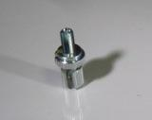 | GAS EQUALIZER MINI | 3,68
100.030 | CP.Distanziali Ruota Ant.ESTERNI | 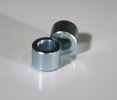 | Ext.Front Wheel Spacer (2pcs) | 6,67
100.031 | CP.Distanziali Inf.Motore (xOgni Modello C/Rinvio) | 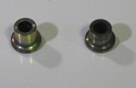 | Engine Bottom Spacer(2pcs-for each model w/driving gear) | 11,88
100.031/A | CP.Distanziali Inf.Motore Noleggio-JR 95/03 | 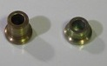 | Engine Bottom Spacer Rental-JR 95/03 (2pcs) | 11,88
100.031/B | CP.Distanziali Sup.Motore 204-5-6-7 | 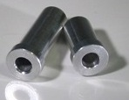 | Engine Top Spacer 204-5-6-7 (2pcs) | 13,02
100.031/C | DISTANZIALE SUP.x JR 205/206/207 | 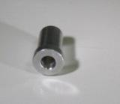 | Engine Top Spacer JR 205-6-7 | 9,03
100.032 | DISTANZIALE Corona(xTutti Mod.) | 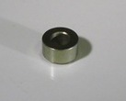 | Sprocket Spacer (x each mod.) | 6,45
100.032/A | CP.DISTANZIALI DISCO-CORONA X ECO | 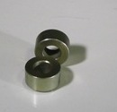 | Sprocket Spacer Brake Discx Eco (2pcs) | 12,90
100.033 | Distanziale Cuscinetti x Canotto di Sterzo | 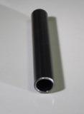 | Steering Shell Bearing Spacer | 3,29
100.033/A | Distanziale Cuscinetti x canotto di sterzo int.midi 203f | 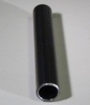 |  | 3,29
100.033/B | DistanzialeCuscinetti x Canotto di Sterzo Int.Mini/Midi 204-5-6-7 | 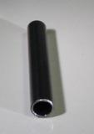 | Int. Steering Shell Bearing Spacer Mini/Midi 204-5-6-7 | 3,29
100.034 | CP.Cuscinetti Sterzo ECO/Noleggio | 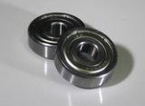 | Steering Bearing ECO/Rental (2pcs) | 5,73
100.034/A | CP.Cuscinetti Sterzo 204-5-6-7 Comp.c/Boccole | 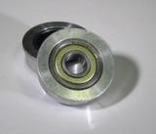 | Steering Bearing 204-5-6-7 Comp.w/Bushing (2pcs) | 17,17
100.035 | PERNO PIASTRE FORCELLA X Mini/Eco/MidiNoleggio/JR | 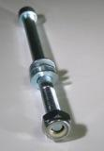 | Fork Mount Pivot Mini/Eco/MidiNoleggio/JR | 5,59
100.035/A | PERNO PIASTRE FORCELLA X MIDI 203F | 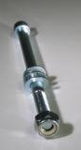 | Fork Mount Pivot Midi 203F | 5,87
100.036 | MANUBRIO X NOLEGGIO | 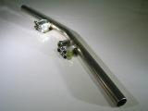 | Rental Handlebar | 25,75
100.037 | CP. PEDANE ECO COMPLETE | 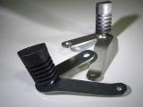 | Feet Support ECO Comp.(2pcs) | 20,76
100.038 | CP. SUPPORTI PEDANE X MIDI 203F | 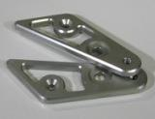 | Feet Supp.connection MIDI 203F (2pcs) | 38,64
100.039 | CP. DISTANZIALI PEDANE MOD. 203F |  | Feet Supp.Spacer mod.203F (2pcs) | 12,89
100.040 | CP. DISTANZIALI PEDANE MOD. ECONOMICA | 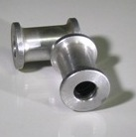 | Feet Supp.Spacer mod.ECO (2pcs) | 12,89
100.045 | CP. PIASTRE PEDANE X MINI MOD. 204/205/206/207 | 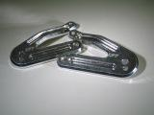 | Feet Support Mount x Mini mod.204-5-6-7 | 38,66
100.045/A | CP. PIASTRE PEDANE X MIDI MOD. 204/205/206/207 |  | Feet Support Mount x Midi mod.204-5-6-7 | 38,66
100.046 | PULSANTINO DI MASSA NUDO | 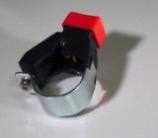 | Earth Release Bare | 6,16
100.047 | PULSANTINO DI MASSA COMPLETO X MINI 01/03 - MIDI 01/02/NOLEGGIO | 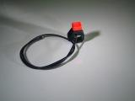 | Earth Release Complete Mini 01/03-Midi | 8,76
100.048 | PULSANTINO DI MASSA COMPLETO X MIDI 03 - MINI-MIDI 204/205/206 - ECO |  | Earth Release Complete Midi 03-Mini-Midi | 8,76
100.049 | PERNO TESTA X 204/205/206/207 | 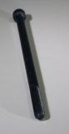 | Pivot x 204/205/206/207 | 5,03
100.049/A | PERNO TESTA X JUNIOR 205/206/207 | 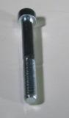 | Pivot x JR 205/206/207 | 5,03
100.050 | PERNO TESTA X ECO | 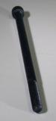 | Pivot x ECO | 5,03
100.051 | PERNO TESTA X ECO CARENA INTEGRALE | 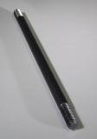 | Pivot x ECO Integral Fairing | 4,86
100.052 | CP. DADI PERNO MOTORE X ECO CARENA INTEGRALE | 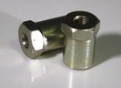 | Engine Pivot Nut x ECO Integral Fairing (2pcs) | 9,03
107.024 | AMMORTIZZATORE DI STERZO ZPF |  | Steering Damper ZPF | 157,40
107.011 | CP. TAPPI IN ALLUMINIO X MANUBRIETTI | 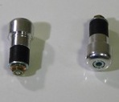 | Aluminium Handlebar Caps (2pcs) | 24,33
100.053 | COPPIA TAPPI QUADRATI SOTTO SELLA | 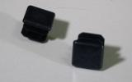 | Squared Caps Under Saddle (2pcs) | 4,30
100.054 | DISTANZIALE CAMPANA POGGIA PEDANA X MIDI 204/205/206/207 | 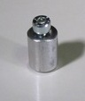 | Feet Support Bell Spacer x Midi 204/205/206/207 | 3,48
100.054/A | CP.DISTANZIALE CAMPANA POGGIA PEDANA X MINI 204/205/206/207 | 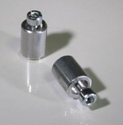 | Feet Support Bell Spacer x Mini 204/205/206/207 (2pcs) | 6,96
100.055 | COPPIA GAMBALETTI COMPLETI X FORCELLE 205/206/207 | 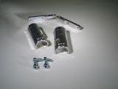 | Complete Covers x Fork 205/206/207 (2pcs) | 38,90
100.056 | KIT TRASFORMAZIONE DA MINI A MIDI MOD.205 |  | Transformation Kit from Mini to Midi mod.205 | 158,76
100.056/A | KIT TRASFORMAZIONE DA MINI A MIDI MOD.206 |  | Transformation Kit from Mini to Midi mod.206 | 174,64
100.056/B | KIT TRASFORMAZIONE DA MINI A MIDI MOD.207 |  | Transformation Kit from Mini to Midi mod.207 | 178,61
100.056/C | KIT TRASFORMAZIONE DA MINI A MIDI MOD.207 IN ALL. |  | Transformation Kit from Mini to Midi mod.207 Alluminium | 0,00
100.057 | KIT TRASFORMAZIONE DA MIDI A MINI MOD.205 |  | Transformation Kit from Midi to Mini mod.205 | 158,76
100.057/A | KIT TRASFORMAZIONE DA MIDI A MINI MOD.206 |  | Transformation Kit from Midi to Mini mod.206 | 174,64
100.057/B | KIT TRASFORMAZIONE DA MIDI A MINI MOD.207 |  | Transformation Kit from Midi to Mini mod.207 | 178,61
100.058 | CP.SUPPORTO MOTORE NOLEGGIO | 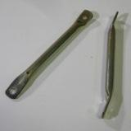 | Topspacer engine rental (2pcs) | 0,00
100.059 | BOCCOLE CON VITI X CAVALLETTO MIDI | 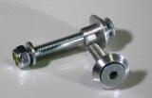 | Buckles with screws x easel Midi | 0,00
100.060 | BOCCOLE CON VITI X CAVALLETTO MINI | 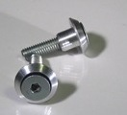 | Buckles with screws x easel Mini | 0,00

